85. Maximal Rectangle
Hard

Given a rows x cols binary matrix filled with 0's and 1's, find the largest rectangle containing only 1's and return its area.

Example 1:
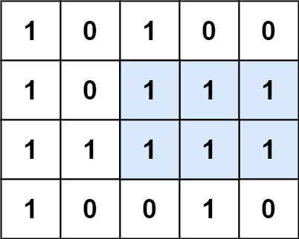
Input: matrix = [["1","0","1","0","0"],["1","0","1","1","1"],["1","1","1","1","1"],["1","0","0","1","0"]]
Output: 6
Explanation: The maximal rectangle is shown in the above picture.
Example 2:
Input: matrix = [["0"]]
Output: 0
Example 3:
Input: matrix = [["1"]]
Output: 1

Constraints:
- rows == matrix.length
- cols == matrix[i].length
- 1 <= row, cols <= 200
- matrix[i][j] is '0' or '1'.

